|  |
| --- |
| Nepali OUTREACH Ministry Living Water Community Church, ChicagoJanuary and February, 2022 Dear co-laborers in Christ, Jaimashi!  Thank you for your continuous prayer and support for the ministry of Living Water Community Church (LWCC). I would like to share our Nepali outreach ministry report from the last two months, January and February 2022. Apart from the Bible Study, Prayers, and Leadership development training, I was also involved in finding jobs for the Nepali community members and counseling Nepali pastors who are seeking more advanced theological training.    **Midwest Bible Study Fellowship**  As in the past, Midwest pastors and leaders met regularly each Thursday 6 pm-7:30 pm for Bible study and prayers. This is a place to pray, Bible study, discuss, share vision and grow in discipleship. I often teach/train leaders in this fellowship, but am shifting priorities to team building and inviting the other participating pastors to teach. Pastors Kishor Gurung (Minnesota), Ganesh Paudyal (Illinois) and Gagan Gurung (Missouri) are  Pastor Kishor Gurung leading on Bible Study  currently teaching with me and doing  fantastic work.  **Leadership Training**  **Vision Seminar**  The Midwest Nepal Churches organized a one-dayleadership seminar on February 25 to explore the vision for the Church and training  of future leaders for the vision. I and Pastor Joseph Gurung (Iowa) led the sessions.    Midwest leadership Seminar |

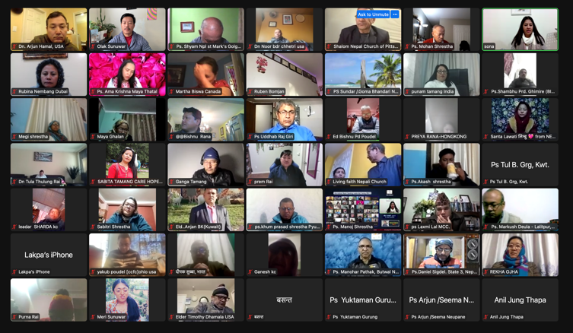

**International Nepali-Speaking Leadership Training (INSLT)**

I have been teaching '"Christ and Culture" as part of the International Nepali-Speaking Leadership Training twice a month, every other Tuesday. Starting in March, however, I plan to devote several sessions to “Christian Responses to War”. I am praying to encourage Nepali Christian leaders’ to consider different ethical perspectives. Please join me in this prayer.

International Leadership Training

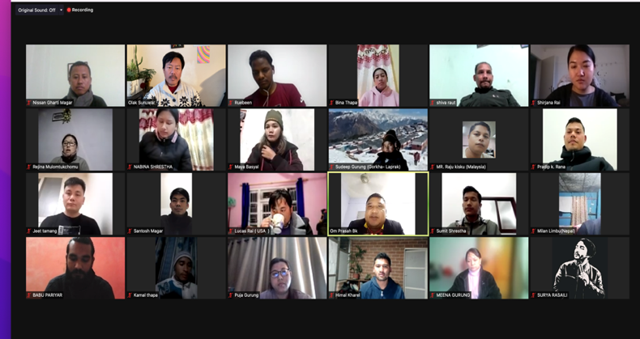**Nepali International Theological Seminary (NITS)**

I taught “Introduction to Christian Ethics” to NITS students. The seminary focuses on providing online theological education using Nepali resources as leaders struggle to understand the English language resources. Surprisingly, many students who live in foreign countries; S. Korea, Malaysia, Kuwait, Denmark, and the USA are eagerly participating. They are connected to ministry among the Nepali communities in these countries. Arranging a time that works for everyone across several international time zones has been a challenge.

Nepali International Theological Seminary Students

**Community Engagement**

I had a good time talking with Pastor Joseph Gurung as he was asking for ideas for further theological study. He has several short-term leadership training courses but does not have any formal college education. I provided information about AMBS’s Journey program.

The Nepali congregation at Living Water Community Church is the only Nepali-speaking congregation in the Chicago urban area. Therefore, Nepalese from the wider community approach the church for assistance, such as finding jobs. Several individuals faced uncertainties at their workplace due to Covid and asked for help in finding more stable employment. This past month, I offered assistance to prepare resumes, cover letters, and job applications and arranged interviews at a nearby company. Three candidates have been hired and already started work, and another candidate is in the interview process.

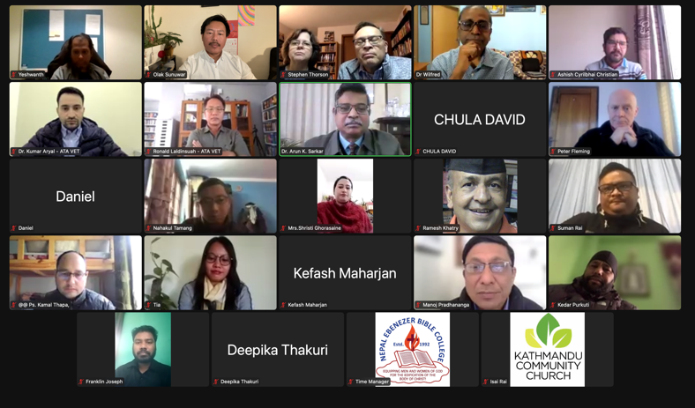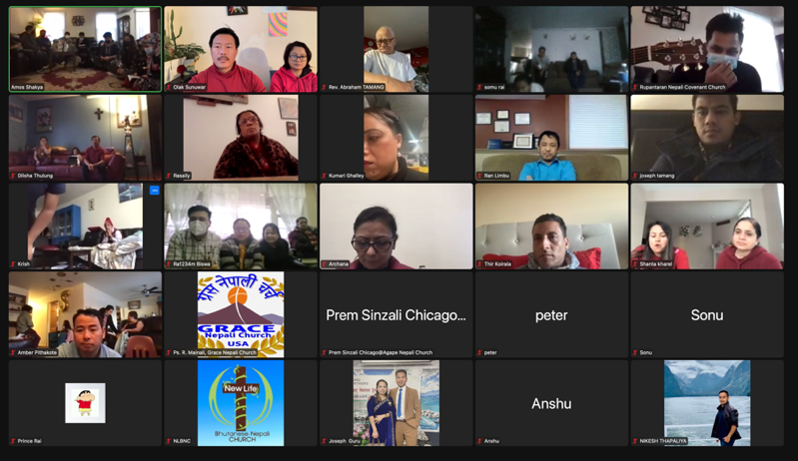

Virtual memorial service of Sukumaya Shakya, mother of pastor Amos Shakya on January 22, 2022.

Meeting with Asian Theological Association (ATA) Board on 8 February 2022 to discuss the theological education and leadership development program of Nepal Ebenezer Bible College. I graduated from this seminary in 2005 and have been teaching here recently.

Many Nepali community members have been blessed through this ministry. Once again, thank you for your prayers and support.

Peace,

Olak B. Sunuwar, Pastor

Living Water Community Church

6808 N Ashland Blvd. Chicago, IL 60626

Email: [olakswr@gmail.com](mailto:olakswr@gmail.com)

Phone: 312-4782129